

LAB REPORT
CSE232: Compiler Design Lab

03
[Report Number]

Topic: Write a calculator using Flex and Bison.

Submitted To
Mushfiqur Rahman Chowdhury (MRC)
Lecturer
Department of CSE, Daffodil International University

Submitted By
Student ID: 0242220005101781
Section: 63 N
Student Name: SHAHARIAR HOSSAIN

Date of Assignment Distribution: 30 November 2025
Date of Assignment Submission: 11 November 2025

Experiment No: 03 |  | Mapping: CO1 and CO2
Experiment Name | Write a calculator using Flex and Bison.
Experiment Details:
Write a calculator using Flex and Bison that supports:
1. Basic arithmetic operations (+,-,/,*)
2. Parentheses
3. Make sure that the operations happen in the proper order.
Lexer.l:
%{
#include "parser.tab.h"
#include <stdio.h>
#include <stdlib.h>
%}

%%

[0-9]+(\.[0-9]+)? { yylval.d = atof(yytext); return NUMBER; }
[ \t]+ { /* skip whitespace */ }
\n { return '\n'; }
"+" { return '+'; }
"-" { return '-'; }
"*" { return '*'; }
"/" { return '/'; }
"(" { return '('; }
")" { return ')'; }
. { fprintf(stderr, "Unknown character: %s\n", yytext); }

%%

int yywrap(void) { return 1; }

Parser.y:
%{
#include <stdio.h>
#include <stdlib.h>

void yyerror(const char *s);
int yylex(void);
%}

%union {
double d;
}

%token <d> NUMBER
%left '+' '-'
%left '*' '/'
%right UMINUS

%type <d> expr

%%

input:
/* empty */
| input line
;

line:
'\n'
| expr '\n' { printf("Result: %g\n", $1); }
;

expr:
expr '+' expr { $$ = $1 + $3; }
| expr '-' expr { $$ = $1 - $3; }
| expr '*' expr { $$ = $1 * $3; }
| expr '/' expr {
if ($3 == 0) { yyerror("division by zero"); $$ = 0; }
else $$ = $1 / $3;
}
| '(' expr ')' { $$ = $2; }
| '-' expr %prec UMINUS { $$ = -$2; }
| NUMBER { $$ = $1; }
;

%%

extern FILE *yyin;

void yyerror(const char *s) { fprintf(stderr, "Error: %s\n", s); }

int main(int argc, char *argv[]) {
if (argc > 1) {
FILE *file = fopen(argv[1], "r");
if (!file) {
fprintf(stderr, "Error: Cannot open file %s\n", argv[1]);
return 1;
}
yyin = file;
}
return yyparse();
}

tests.txt:
3+4*2
(1+2)*3
-5+2
10/2-1
2*3+4*5
100-50+25
(10+5)*2-3
12/3/2
5*-2
-(3+2)
1.5+2.5
(100/10)*2+5
Command:
flex lexer.l
clang lex.yy.c -o lexer
./parser tests.txt
./parser
Obtained Output:
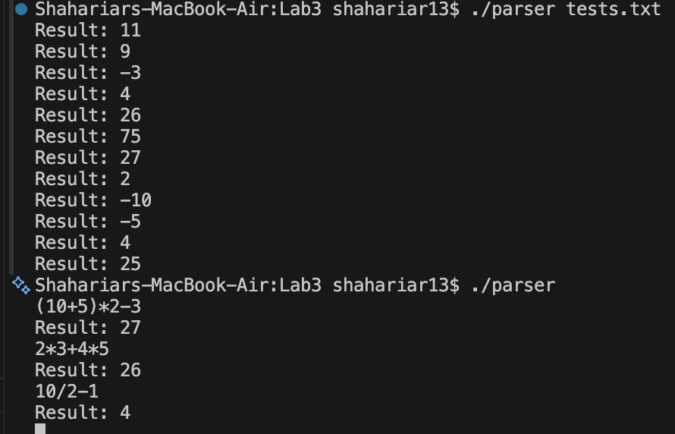 | Desired Output?
 | YES
Alternative Steps/Solution (If any):
None.
Observation/ Comments:
I have implemented a Flex lexer and a Bison parser to create a simple calculator that supports basic arithmetic operations (+, -, *, /), parentheses, and respects operator precedence.
Appendix A: Course Outcomes, Complex Engineering Problems (EP) and Complex Engineering Activities (EA) Addressing.

Table: CSE312 Course Outcomes (COs) with Mappings
COs | CO Statements | POs | Learning  Domains | Knowledge  Profile | Complex  Engineering  Problem | Complex Engineering  Activities
CO1 | Demonstrate a comprehensive understanding of fundamental database management concepts, including the relational data model, normalization techniques, and SQL basics. | PO1 | C2  A2  P2 | K2  K3  K4  K8 | EP1  EP4
CO2 | Design, implement and optimize relational databases, incorporating advanced SQL queries, indexing techniques and query optimization strategies. | PO3 | C3  A3  P3 | K2  K3  K4  K6  K8 | EP1  EP2  EP7 | EA3
CO3 | Understand and Analyze security measures, distributed database architectures and emerging trends in database management, demonstrating an understanding of the broader context and challenges in the field. | PO5 | C4  A4  P3 | K6 | EP4

Table: Addressing CO (1 to 3), Knowledge Profile (K), Attainment of Complex Engineering
Problems (EP):
SN | Engineering Problem (EP) Definition | Attain  Ment | CO | Justification  (with Knowledge Profile)
01 | EP1: Depth  of  Knowledge  required | Yes/No | CO1, CO2
02 | EP2: Range  of  Conflicting  Requirement  s | Yes/No | CO2
03 | EP4:  Familiarity  of Issues | Yes/No | CO1, CO3
04 | EP7:  Interdependence | Yes/No | CO2

Table: Addressing COs
SN | COs | Attainment | Justification
01 | CO1 | Yes/No | These Lab activities attain CO1 by.
02 | CO2 | Yes/No | N/A
03 | CO3 | Yes/No | These Lab activities attain CO3 by.

Table: Lab-Wise Recommended Topics

Lab Class No. | Proposed Activity
Lab 1 | Write a Flex program to recognize the following types of strings.
Lab 2 | Write a Flex program to recognize the following types of strings.
Lab 3 | Write a calculator using Flex and Bison.

